

**Postgraduate Certificate in Software Design with Artificial Intelligence**

**Data Visualisation - (AL\_KSAIG\_9\_1)**

**Final Assignment – Covid-19 Visualisation**

**Student ID:**

A00267948

**Student Name:**

Daniel Foth

**Git Repository:**

<https://github.com/DanielsHappyWorks/data-vis-fianl-covid-19-sk>

**Visualisation Dashboard:**

<https://danielshappyworks.github.io/data-vis-fianl-covid-19-sk/>

Contents

[Declaration 4](#_Toc39694173)

[Introduction 5](#_Toc39694174)

[Data 6](#_Toc39694175)

[Datasets 6](#_Toc39694176)

[The Covid-19 Data Set 6](#_Toc39694177)

[The Country Data Set 6](#_Toc39694178)

[The Country and Continent Codes List 6](#_Toc39694179)

[Pre-Processing 7](#_Toc39694180)

[Software 8](#_Toc39694181)

[Technology Stack 8](#_Toc39694182)

[Source Control 8](#_Toc39694183)

[Deployment 8](#_Toc39694184)

[Customisation 8](#_Toc39694185)

[Temporal Analysis 10](#_Toc39694186)

[Statistics 10](#_Toc39694187)

[Global 10](#_Toc39694188)

[Countries Surrounding South Korea 10](#_Toc39694189)

[South Korea 10](#_Toc39694190)

[Daily Data 10](#_Toc39694191)

[Global 10](#_Toc39694192)

[Countries Surrounding South Korea 10](#_Toc39694193)

[South Korea 11](#_Toc39694194)

[Cumulative Data 11](#_Toc39694195)

[Global 11](#_Toc39694196)

[Countries Surrounding South Korea 11](#_Toc39694197)

[South Korea 11](#_Toc39694198)

[Geospatial Analysis 12](#_Toc39694199)

[Map 12](#_Toc39694200)

[Global 12](#_Toc39694201)

[Countries Surrounding South Korea 12](#_Toc39694202)

[South Korea 12](#_Toc39694203)

[Continents 12](#_Toc39694204)

[Total Cases 12](#_Toc39694205)

[Total Deaths 12](#_Toc39694206)

[Recent Cases 12](#_Toc39694207)

[Recent Deaths 12](#_Toc39694208)

[Countries Biggest Impact 12](#_Toc39694209)

[Total Cases 12](#_Toc39694210)

[Total Deaths 12](#_Toc39694211)

[Recent Cases 12](#_Toc39694212)

[Recent Deaths 12](#_Toc39694213)

[Conclusions 13](#_Toc39694214)

[References 14](#_Toc39694215)

# Declaration

I declare that this report was composed by myself, that the work contained

herein is my own except where explicitly stated otherwise in the text, and that

this work has not been submitted for any other degree or processional

qualification except as specified.

# Introduction

Coronavirus, better known as Covid-19, is spread in sneeze or cough droplets. (1) Covid-19 can survive for up to 72 hours on plastic and stainless steel, less than 4 hours on copper and less than 24 hours on cardboard but household disinfectants will kill the virus on surfaces (1) where it’s present.

It can take up to 14 days for symptoms of Covid-19 to appear. They can be like the symptoms of cold and flu. (2) The most common symptoms include a fever, cough and shortness of breath. The consensus around the world is that if you have any of these symptoms, you should behave as if you have the virus and self-isolate for 14 days (2) and contact a doctor as needed.

As part of this report a custom dashboard has been created to visualise the Covid-19 pandemic. The dashboard uses the web stack to create visualisations based on time a geographic location data sourced from ECDC, Google and Datahub.

This report will look at the global effects of the pandemic, zoning in specifically on South Korea and its general location. Throughout the report we will see how much South Korea was affected and what stage of the pandemic the country is at. We will also discuss the future to come.

# Data

Three different data sets are used for the analysis of Covid-19. These datasets have been refined and used to create visualisations. All the datasets were sourced on the 13th of April 2020.

## Datasets

### The Covid-19 Data Set

The following dataset has been sourced from ECDC. (3)

It contains global information about the Covid-19 Pandemic ranging from 31st December 2019 to the 13th of April 2020.

Data of Interest:

1. Date (Day, Month, Year) – Can be used to plot cases and deaths against time.
2. Cases – Can be used to get total, daily and cumulative cases.
3. Deaths – Can be used to get total, daily and cumulative deaths.
4. CountriesAndTerritories – Can be used as the locations display name.
5. geoId – Can be used to map locations geographically.
6. countryterritoryCode – Can be used to map locations geographically.

### The Country Data Set

The following dataset has been sourced from Google. (4)

This dataset contains latitude and longitude data that allows us to accurately plot Covid-19 information on a map.

Data of Interest:

1. Country – Can be used to join this dataset with the covid-19 dataset by geoId.
2. Latitude – Can be used to plot data on a map.
3. Longitude – Can be used to plot data on a map.

### The Country and Continent Codes List

The following dataset has been sourced from JohnSnowLabs on Datahub. (5)

This dataset contains information that allows us to map continent to country data which allows for plotting of Covid-19 information based on continents.

Data of Interest:

1. Continent\_Name – Can be used as the display name for data grouped by continents.
2. Continent\_Code – Can be used to visualise data by continent.
3. Two\_Letter\_Country\_Code – Can be used to join this dataset with the covid-19 dataset by geoId.
4. Three\_Letter\_Country\_code – Can be used to join this dataset with the covid-19 dataset by countryterritoryCode.

## Pre-Processing

Missing fields in the data such as country codes and latitude and longitude data meant that some pre processing needed to be done. Any missing field was manually added to the dataset by use of Google Maps.

For some fields like the population data for 2018 in the Covid-19 dataset (3) too many fields were missing. This meant that it wasn’t worth trying to fill in the gaps to make visualisations with those fields.

Since the bespoke software developed for the purposes of visualising the data is written in JavaScript the data had to be processed into Json objects. This was done for ease of importing and processing of the data in the specific environment. Three Json files can be found in the ./src/\_data directory in the project structure.

# Software

All the visualisations used in this report are created using custom software which employs graphing frameworks and allow for creation of an interactive dashboard. The code is generic enough to use any country’s data to display visualisations if its present in the dataset.

The Dashboard can be accessed via the following link: <https://danielshappyworks.github.io/data-vis-fianl-covid-19-sk/>.

It’s highly recommended to look at the visualisations on the dashboard as they have useful tooltips that help with readability of the exact figures present.

## Technology Stack

The web development stack, leveraging a set of useful libraries, was used to develop the dashboard. The stack consists of HTML, JavaScript and CSS.

The used libraries include:

1. ReactJs (6) – React leverages components to allow encapsulation of code. This makes it easy to crate single page user interfaces over multiple files with proper separation and templating.
2. Materialize (7) – A Bootstrap like library, that comes with pre-built HTML and CSS components that allow for quick and responsive web design.
3. Chart.js (8) – This library provides a way to create a multitude of interactive graphs with tooltips and legends.
4. Leaflet (9) – Leaflet provides interactive maps that can be customised with markers to display data geographically.

## Source Control

GitHub has been used as the source control for this project.

The code is available here: <https://github.com/DanielsHappyWorks/data-vis-fianl-covid-19-sk>

## Deployment

The dashboard has been deployed on GitHub pages. GitHub pages was used as its easy to use for single page applications that run on the web stack. It only takes one command “npm run deploy” to deploy any changes after package.json file is configured correctly.

## Customisation

It’s possible to pass in parameters via to URL to customise the content. The parameters are:

1. live=true – by default it displays cached data from the 13th of April 2020
2. country=Ireland,United\_Kingdom – by default the country data is South Korea

Opening the dashboard with the live=true parameter will pull the latest Covid-19 data from ECDC. This takes a bit of time as the data is pulled live from the ECDC servers.

Opening the dashboard with the country= Ireland,United\_Kingdom will use the specified countries in the graphs Country Data section of the Dashboard. Countries need to be “,” separated and use “\_” instead of spaces to work properly.

Sample customisation:

<https://danielshappyworks.github.io/data-vis-fianl-covid-19-sk/?live=true&country=Ireland,United_Kingdom>

# Temporal Analysis

In this section we will look at how the status of the pandemic on 13th of April 2020 and how it evolved over time for South Korea, the countries surrounding it and the world with the data leading up to the 13th of April 2020.

Note all the graphs are inside the visualisations.zip in the Temporal folder at their normal size. The images in the document are scaled down for readability purposes.

## Statistics

### Global

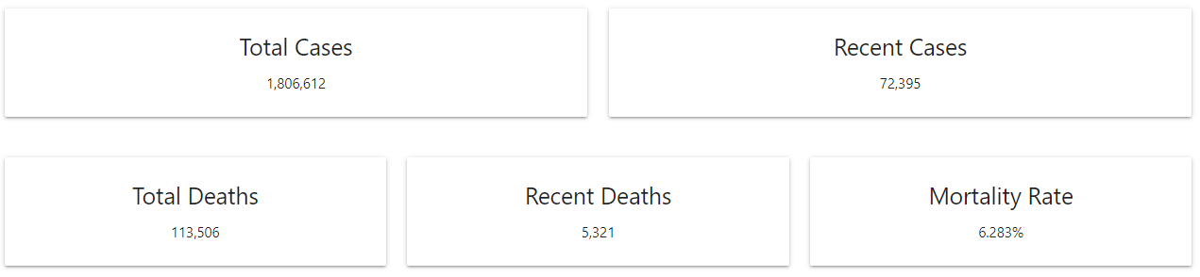

### South Korea and The Countries Surrounding It

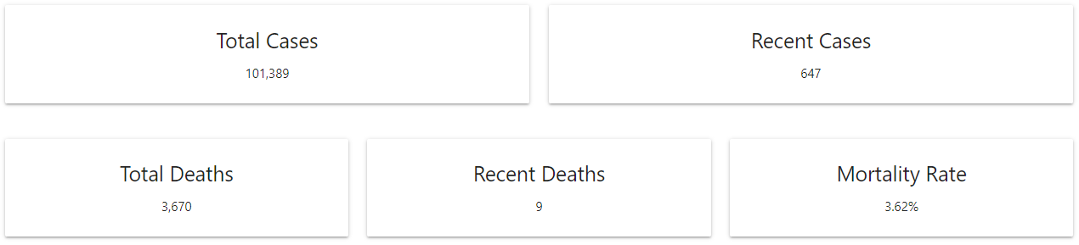

South Korea Japan China Taiwan No North Korea

### South Korea

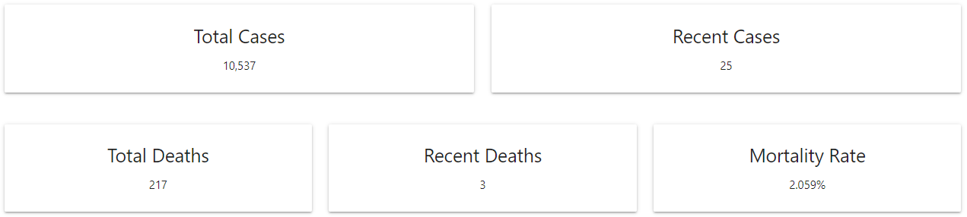

Just sk

## Daily Data

### Global

#### Cases

|  |  |
| --- | --- |
|  |  |
|  |  |

#### Deaths

|  |  |
| --- | --- |
|  |  |
|  |  |

### South Korea and The Countries Surrounding It

South Korea Japan China Taiwan No North Korea

#### Cases

|  |  |
| --- | --- |
|  |  |
|  |  |

#### Deaths

|  |  |
| --- | --- |
|  |  |
|  |  |

### South Korea

#### Cases

|  |  |
| --- | --- |
|  |  |
|  |  |

#### Deaths

|  |  |
| --- | --- |
|  |  |
|  |  |

## Cumulative Data

### Global

#### Cases

|  |  |
| --- | --- |
|  |  |
|  |  |

#### Deaths

|  |  |
| --- | --- |
|  |  |
|  |  |

### South Korea and The Countries Surrounding It

#### Cases

|  |  |
| --- | --- |
|  |  |
|  |  |

#### Deaths

|  |  |
| --- | --- |
|  |  |
|  |  |

### South Korea

#### Cases

|  |  |
| --- | --- |
|  |  |
|  |  |

#### Deaths

|  |  |
| --- | --- |
|  |  |
|  |  |

# Geospatial Analysis

In this section we will look at how the pandemic is impacting the world geographically on the 13th of April 2020 for South Korea, the countries surrounding it and the world.

Note all the graphs are inside the visualisations.zip in the Geospatial folder at their normal size. The images in the document are scaled down for readability purposes.

## Map

### Global

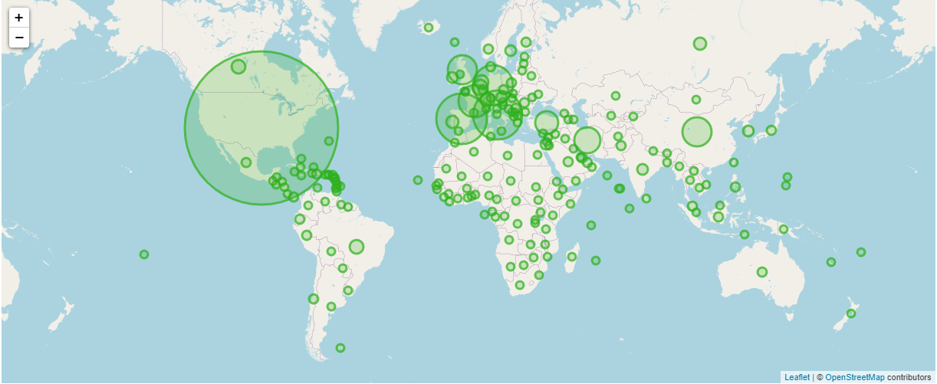

### South Korea and The Countries Surrounding It

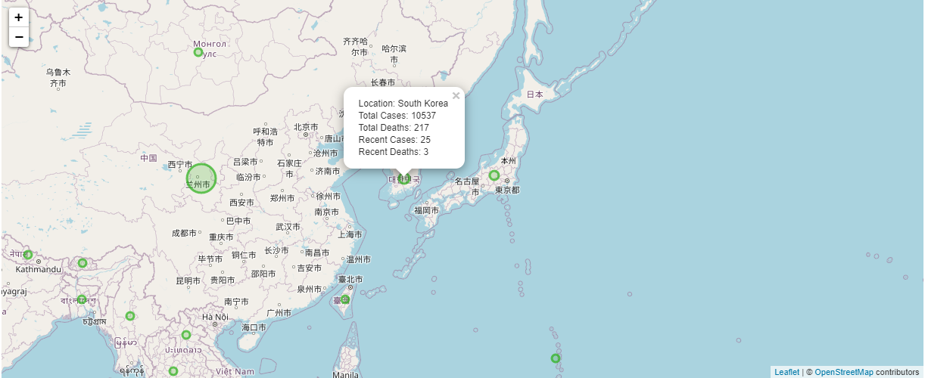

### South Korea

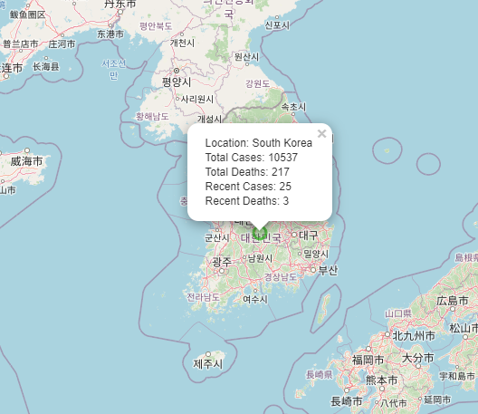

## Continents

### Total

|  |  |
| --- | --- |
| Cases | Deaths |
|  |  |
|  |  |
|  |  |
|  |  |
|  |  |

### Recent

|  |  |
| --- | --- |
| Cases | Deaths |
|  |  |
|  |  |
|  |  |
|  |  |
|  |  |

How Asia compares

## Countries with Biggest Impact

### Total

|  |  |
| --- | --- |
| Cases | Deaths |
|  |  |
|  |  |
|  |  |
|  |  |
|  |  |

### Recent

|  |  |
| --- | --- |
| Cases | Deaths |
|  |  |
|  |  |
|  |  |
|  |  |
|  |  |

Top 10

How Asia compares

How SK comnpares

# Conclusions

wrap up your analysis and visualisation. Draw conclusions and

make predictions, etc

# References

x

|  |  |
| --- | --- |
| 1. | HSE. How coronavirus is spread. [Online].; 2020 [cited 2020 May 06. Available from: <https://www2.hse.ie/conditions/coronavirus/how-coronavirus-is-spread.html>. |
| 2. | HSE. Symptoms of coronavirus. [Online].; 2020 [cited 2020 May 06. Available from: <https://www2.hse.ie/conditions/coronavirus/symptoms.html>. |
| 3. | ECDC. COVID-19 situation update worldwide. [Online].; 2020 [cited 2020 May 06. Available from: <ecdc.europa.eu>. |
| 4. | Google. countries.csv. [Online]. [cited 2020 May 06. Available from: <https://developers.google.com/public-data/docs/canonical/countries_csv>. |
| 5. | JohnSnowLabs. Country and Continent Codes List. [Online]. [cited 2020 May 06. Available from: <https://datahub.io/JohnSnowLabs/country-and-continent-codes-list#data-cli>. |
| 6. | Facebook. React A JavaScript library for building user interfaces. [Online].; 2020 [cited 2020 May 06. Available from: <https://reactjs.org/>. |
| 7. | Materialize. Materialize A modern responsive front-end framework based on Material Design. [Online].; 2020 [cited 2020 May 06. Available from: <https://materializecss.com/>. |
| 8. | Chart.js. Chart.js Simple yet flexible JavaScript charting for designers & developers. [Online]. [cited 2020 May 06. Available from: <https://www.chartjs.org/>. |
| 9. | Leaflet. Leaflet an open-source JavaScript library. [Online].; 2019 [cited 2020 May 06. Available from: <https://leafletjs.com/>. |

x

# Appendix

# Link to get global time-based diagrams:

[https://danielshappyworks.github.io/data-vis-fianl-covid-19-sk/?country=Afghanistan,Albania,Algeria,Andorra,Angola,Anguilla,Antigua\_and\_Barbuda,Argentina,Armenia,Aruba,Australia,Austria,Azerbaijan,Bahamas,Bahrain,Bangladesh,Barbados,Belarus,Belgium,Belize,Benin,Bermuda,Bhutan,Bolivia,Bonaire\_Saint\_Eustatius\_and\_Saba,Bosnia\_and\_Herzegovina,Botswana,Brazil,British\_Virgin\_Islands,Brunei\_Darussalam,Bulgaria,Burkina\_Faso,Burundi,Cambodia,Cameroon,Canada,Cape\_Verde,Cayman\_Islands,Central\_African\_Republic,Chad,Chile,China,Colombia,Congo,Costa\_Rica,Cote\_dIvoire,Croatia,Cuba,Cura%C3%A7ao,Cyprus,Czechia,Democratic\_Republic\_of\_the\_Congo,Denmark,Djibouti,Dominica,Dominican\_Republic,Ecuador,Egypt,El\_Salvador,Equatorial\_Guinea,Eritrea,Estonia,Eswatini,Ethiopia,Falkland\_Islands\_(Malvinas),Faroe\_Islands,Fiji,Finland,France,French\_Polynesia,Gabon,Gambia,Georgia,Germany,Ghana,Gibraltar,Greece,Greenland,Grenada,Guam,Guatemala,Guernsey,Guinea,Guinea\_Bissau,Guyana,Haiti,Holy\_See,Honduras,Hungary,Iceland,India,Indonesia,Iran,Iraq,Ireland,Isle\_of\_Man,Israel,Italy,Jamaica,Japan,Jersey,Jordan,Kazakhstan,Kenya,Kosovo,Kuwait,Kyrgyzstan,Laos,Latvia,Lebanon,Liberia,Libya,Liechtenstein,Lithuania,Luxembourg,Madagascar,Malawi,Malaysia,Maldives,Mali,Malta,Mauritania,Mauritius,Mexico,Moldova,Monaco,Mongolia,Montenegro,Montserrat,Morocco,Mozambique,Myanmar,Namibia,Nepal,Netherlands,New\_Caledonia,New\_Zealand,Nicaragua,Niger,Nigeria,North\_Macedonia,Northern\_Mariana\_Islands,Norway,Oman,Pakistan,Palestine,Panama,Papua\_New\_Guinea,Paraguay,Peru,Philippines,Poland,Portugal,Puerto\_Rico,Qatar,Romania,Russia,Rwanda,Saint\_Kitts\_and\_Nevis,Saint\_Lucia,Saint\_Vincent\_and\_the\_Grenadines,San\_Marino,Sao\_Tome\_and\_Principe,Saudi\_Arabia,Senegal,Serbia,Seychelles,Sierra\_Leone,Singapore,Sint\_Maarten,Slovakia,Slovenia,Somalia,South\_Africa,South\_Korea,South\_Sudan,Spain,Sri\_Lanka,Sudan,Suriname,Sweden,Switzerland,Syria,Taiwan,Thailand,Timor\_Leste,Togo,Trinidad\_and\_Tobago,Tunisia,Turkey,Turks\_and\_Caicos\_islands,Uganda,Ukraine,United\_Arab\_Emirates,United\_Kingdom,United\_Republic\_of\_Tanzania,United\_States\_of\_America,United\_States\_Virgin\_Islands,Uruguay,Uzbekistan,Venezuela,Vietnam,Yemen,Zambia,Zimbabwe](https://danielshappyworks.github.io/data-vis-fianl-covid-19-sk/?country=Afghanistan,Albania,Algeria,Andorra,Angola,Anguilla,Antigua_and_Barbuda,Argentina,Armenia,Aruba,Australia,Austria,Azerbaijan,Bahamas,Bahrain,Bangladesh,Barbados,Belarus,Belgium,Belize,Benin,Bermuda,Bhutan,Bolivia,Bonaire_Saint_Eustatius_and_Saba,Bosnia_and_Herzegovina,Botswana,Brazil,British_Virgin_Islands,Brunei_Darussalam,Bulgaria,Burkina_Faso,Burundi,Cambodia,Cameroon,Canada,Cape_Verde,Cayman_Islands,Central_African_Republic,Chad,Chile,China,Colombia,Congo,Costa_Rica,Cote_dIvoire,Croatia,Cuba,Cura%C3%A7ao,Cyprus,Czechia,Democratic_Republic_of_the_Congo,Denmark,Djibouti,Dominica,Dominican_Republic,Ecuador,Egypt,El_Salvador,Equatorial_Guinea,Eritrea,Estonia,Eswatini,Ethiopia,Falkland_Islands_(Malvinas),Faroe_Islands,Fiji,Finland,France,French_Polynesia,Gabon,Gambia,Georgia,Germany,Ghana,Gibraltar,Greece,Greenland,Grenada,Guam,Guatemala,Guernsey,Guinea,Guinea_Bissau,Guyana,Haiti,Holy_See,Honduras,Hungary,Iceland,India,Indonesia,Iran,Iraq,Ireland,Isle_of_Man,Israel,Italy,Jamaica,Japan,Jersey,Jordan,Kazakhstan,Kenya,Kosovo,Kuwait,Kyrgyzstan,Laos,Latvia,Lebanon,Liberia,Libya,Liechtenstein,Lithuania,Luxembourg,Madagascar,Malawi,Malaysia,Maldives,Mali,Malta,Mauritania,Mauritius,Mexico,Moldova,Monaco,Mongolia,Montenegro,Montserrat,Morocco,Mozambique,Myanmar,Namibia,Nepal,Netherlands,New_Caledonia,New_Zealand,Nicaragua,Niger,Nigeria,North_Macedonia,Northern_Mariana_Islands,Norway,Oman,Pakistan,Palestine,Panama,Papua_New_Guinea,Paraguay,Peru,Philippines,Poland,Portugal,Puerto_Rico,Qatar,Romania,Russia,Rwanda,Saint_Kitts_and_Nevis,Saint_Lucia,Saint_Vincent_and_the_Grenadines,San_Marino,Sao_Tome_and_Principe,Saudi_Arabia,Senegal,Serbia,Seychelles,Sierra_Leone,Singapore,Sint_Maarten,Slovakia,Slovenia,Somalia,South_Africa,South_Korea,South_Sudan,Spain,Sri_Lanka,Sudan,Suriname,Sweden,Switzerland,Syria,Taiwan,Thailand,Timor_Leste,Togo,Trinidad_and_Tobago,Tunisia,Turkey,Turks_and_Caicos_islands,Uganda,Ukraine,United_Arab_Emirates,United_Kingdom,United_Republic_of_Tanzania,United_States_of_Ame)